**Riassunto sulla geografia dell'Inghilterra:**

The British Isles consist of two main islands: Great Britain (which includes England, Scotland, and Wales) and Ireland (divided into Northern Ireland and Éire). Politically, England, Scotland, Wales, and Northern Ireland form the United Kingdom, which is sometimes referred to simply as Great Britain, though the two terms are not synonymous.

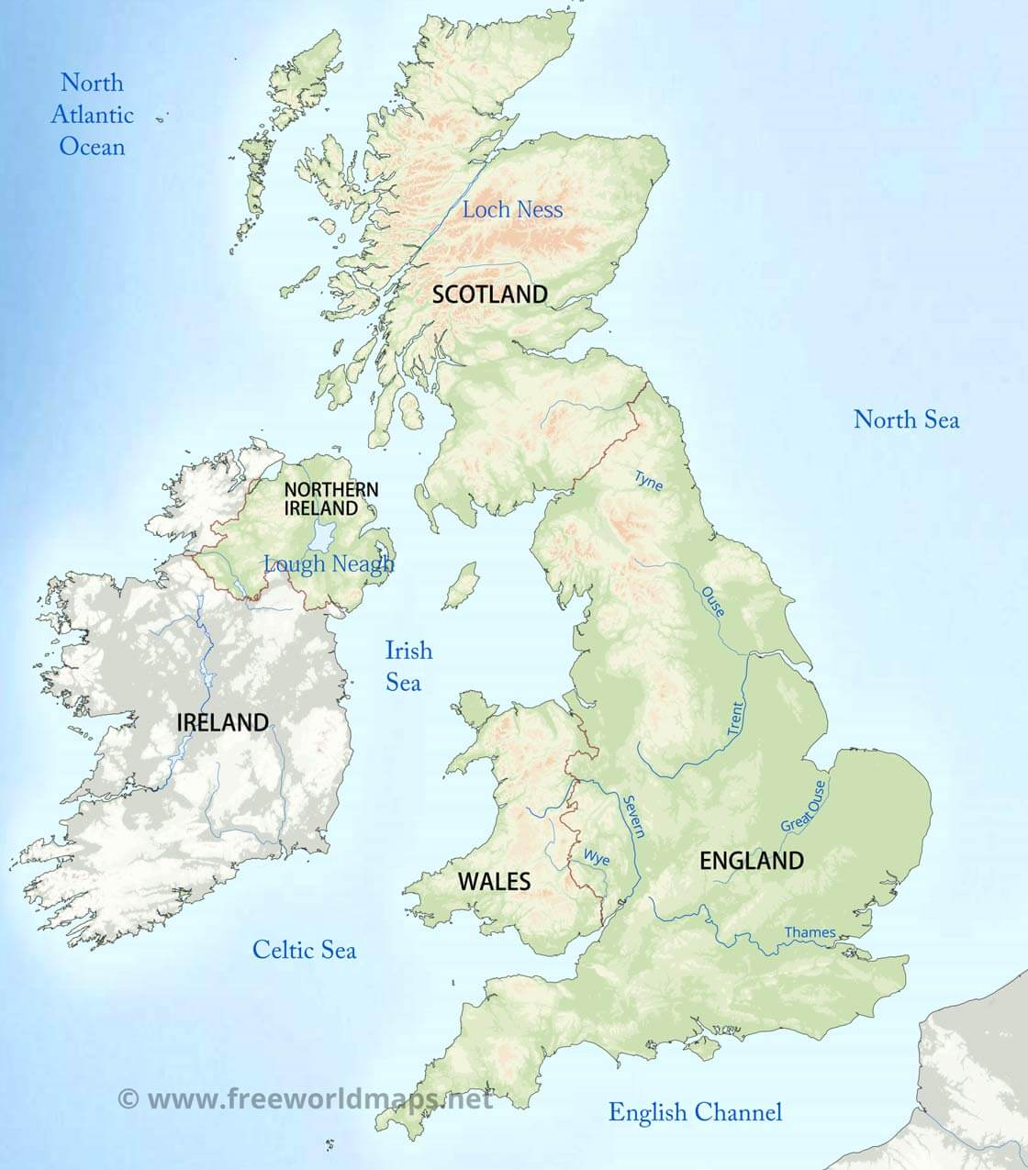

Unlike continental Europe, Great Britain does not have high mountain ranges. The tallest peak is Ben Nevis, standing at 1,343 meters, located in Scotland. The highlands are mainly in the north and west, especially in Scotland and Wales, while the lowlands are concentrated in the southeast, particularly in eastern England.

Mountain ranges include:

* Grampian Mountains (Scotland), home to Ben Nevis.
* Southern Uplands and Cheviot Hills, marking the border between Scotland and England.
* Cumbrian Mountains (northwestEngland).
* Pennines, often called the "backbone of England", extending vertically from north to south.
* Cambrian Mountains (Wales).
* Mourne Mountains (Northern Ireland), with mostly flat terrain.

The region also contains several lakes, including Loch Neagh, the largest lake in Northern Ireland, and Loch Ness, famous for the legendary Loch Ness Monster (Nessy). In England, the Lake District features many interconnected lakes and is a popular Easter holiday destination.

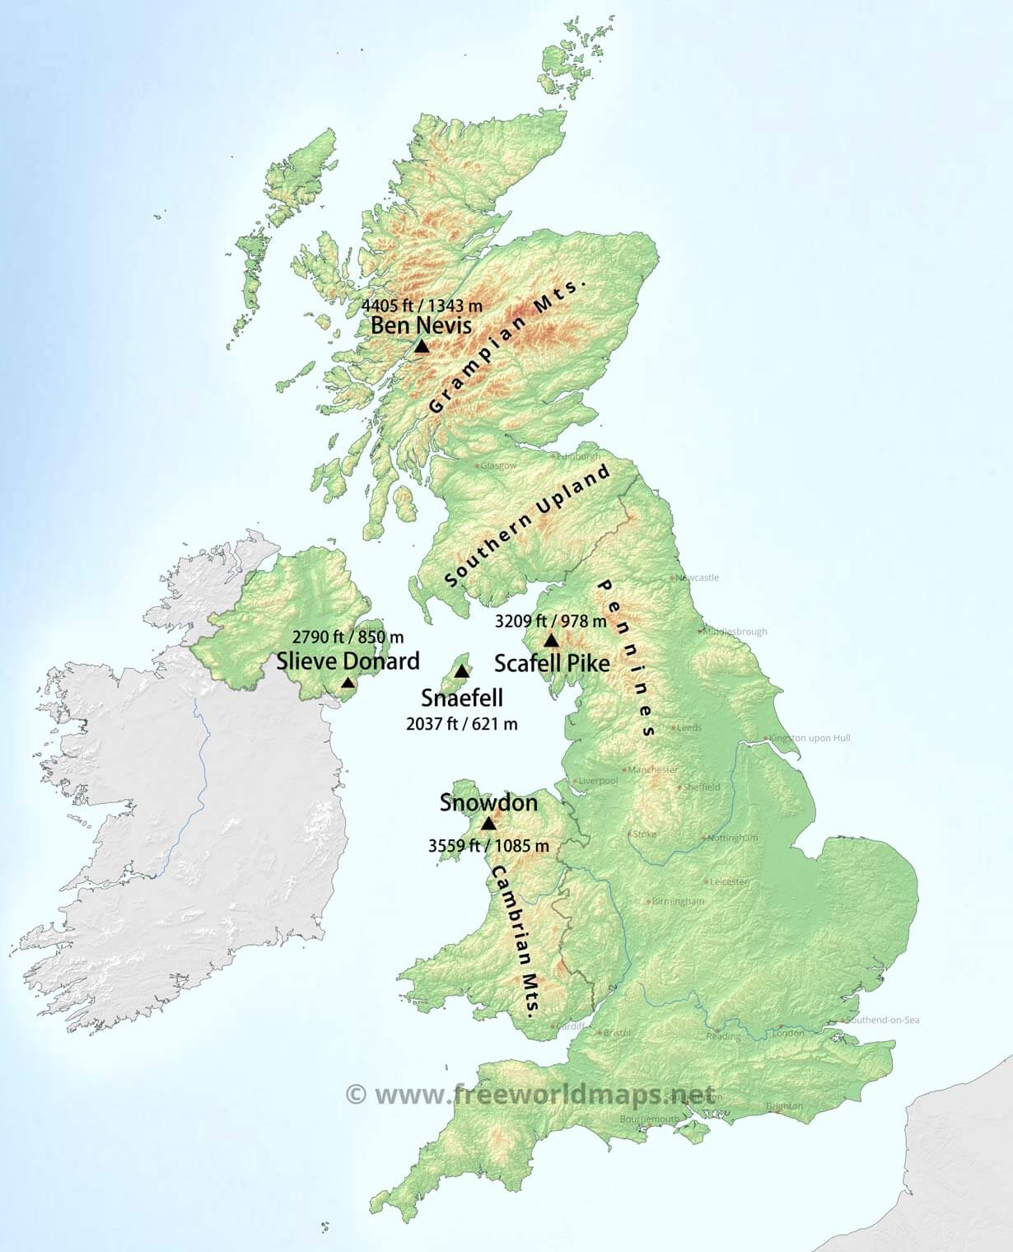

Each nation within the British Isles has its own capital:

* London → England
* Edinburgh → Scotland
* Cardiff → Wales
* Belfast → Northern Ireland
* Dublin → Republic of Ireland (Éire)

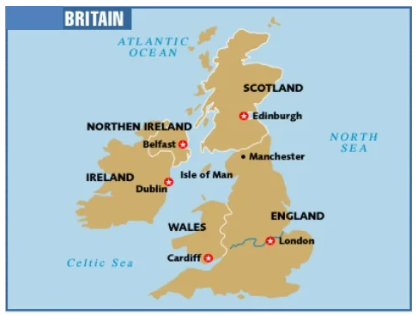

Several major cities are located along river estuaries, which have played a key role in trade and commerce:

* Glasgow → Clyde Estuary
* Edinburgh → Forth Estuary
* Liverpool → Mersey Estuary
* London → ThamesEstuary

British rivers are relatively short. The two longest are the Thames and the Severn, which each measure just over 300 km—about half the length of the Po River in Italy. Despite their size, these rivers are not used for navigation, but their estuaries have made them ideal locations for commercial centers and ports, which have been essential in shaping Britain's economy and global trade.In Northern Ireland, the most important river is the Lagan.

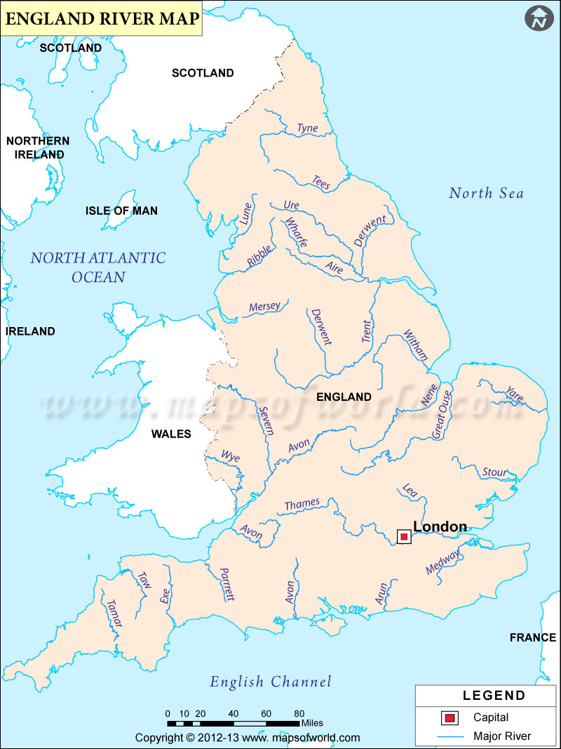

The United Kingdom has always been shaped by its surrounding seas, which have played a crucial role in its geography, economy, and history.

* Atlantic Ocean → Includes Outer Hebrides, Inner Hebrides, Orkney Islands, Shetland Islands.
* North Sea → Borders the east coast of Britain, providing key trade routes.
* Irish Sea → Includes Isle of Man & Anglesey, serving as an important connection between Britain and Ireland.
* English Channel → Includes Isle of Wight, famous in the ‘70s for its hippie movement.

The sea has provided Britain with natural resources such as fish, oil, and natural gas (methane) while also securing its independence for over 900 years. At the same time, it has facilitated connections with other nations, reinforcing Britain’s role in global trade. One of the most significant modern engineering feats is the Channel Tunnel, a major transportation link running beneath the English Channel, connecting Folkestone (UK) with Calais (France).

The tunnel, which is 50 km long (with 38 km underwater), has three tunnels and handles up to 5,000 trains per day. The crossing time is about 55 minutes, revolutionizing travel and trade between Britain and mainland Europe. While the UK can be reached by boat, plane, car, and train, the Channel Tunnel remains the most famous connection between Britain and the continent.

British weather is super unpredictable, and Brits often joke that they experience four seasons in a single day.

* Spring → Warm but never too hot, with flowers blooming and longer daylight hours.
* Summer → Mild but occasionally warm, with rare heatwaves making it the best season for outdoor activities.
* Autumn → Cool and breezy, with plenty of rain. Trees turn red and yellow, creating a stunning natural landscape, especially in parks and forests.
* Winter → Rainy and cold, with occasional snowfall, particularly in Scotland and northern England, where fog and short daylight hours dominate.

Along the west coast, to the left of the Pennines, the climate is mild due to the Gulf Stream, a warm current from Mexico that helps soften winters and contributes to frequent rain & fog. In northern Scotland, the weather is often windy, and in winter, snowy, due to cold Arctic air sweeping down from the north.

